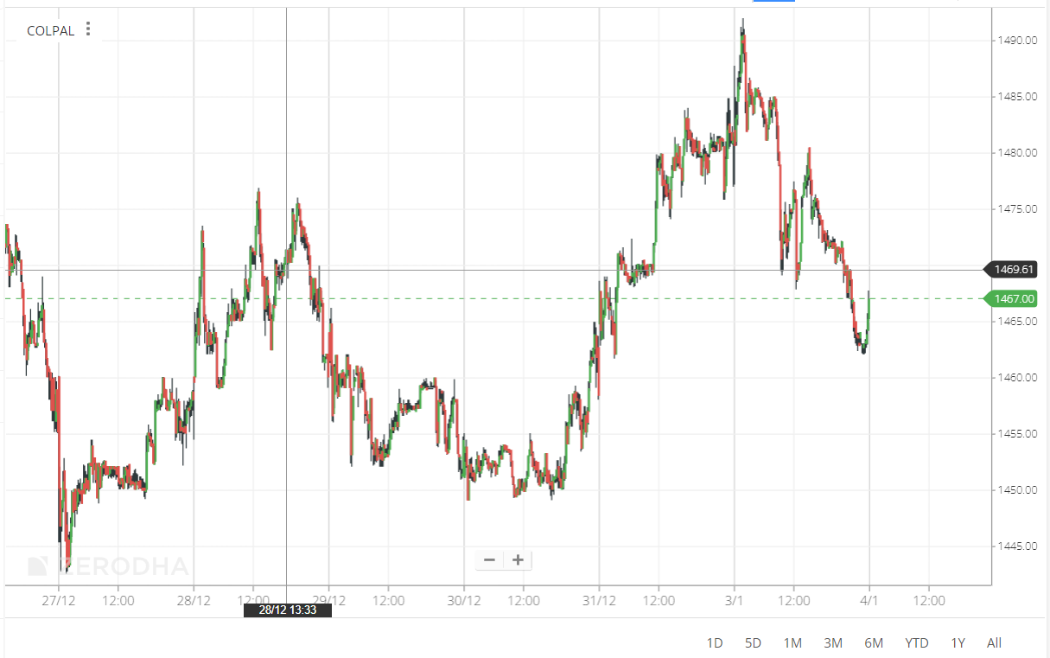

Right click and press inspect

Then click on Netwrok

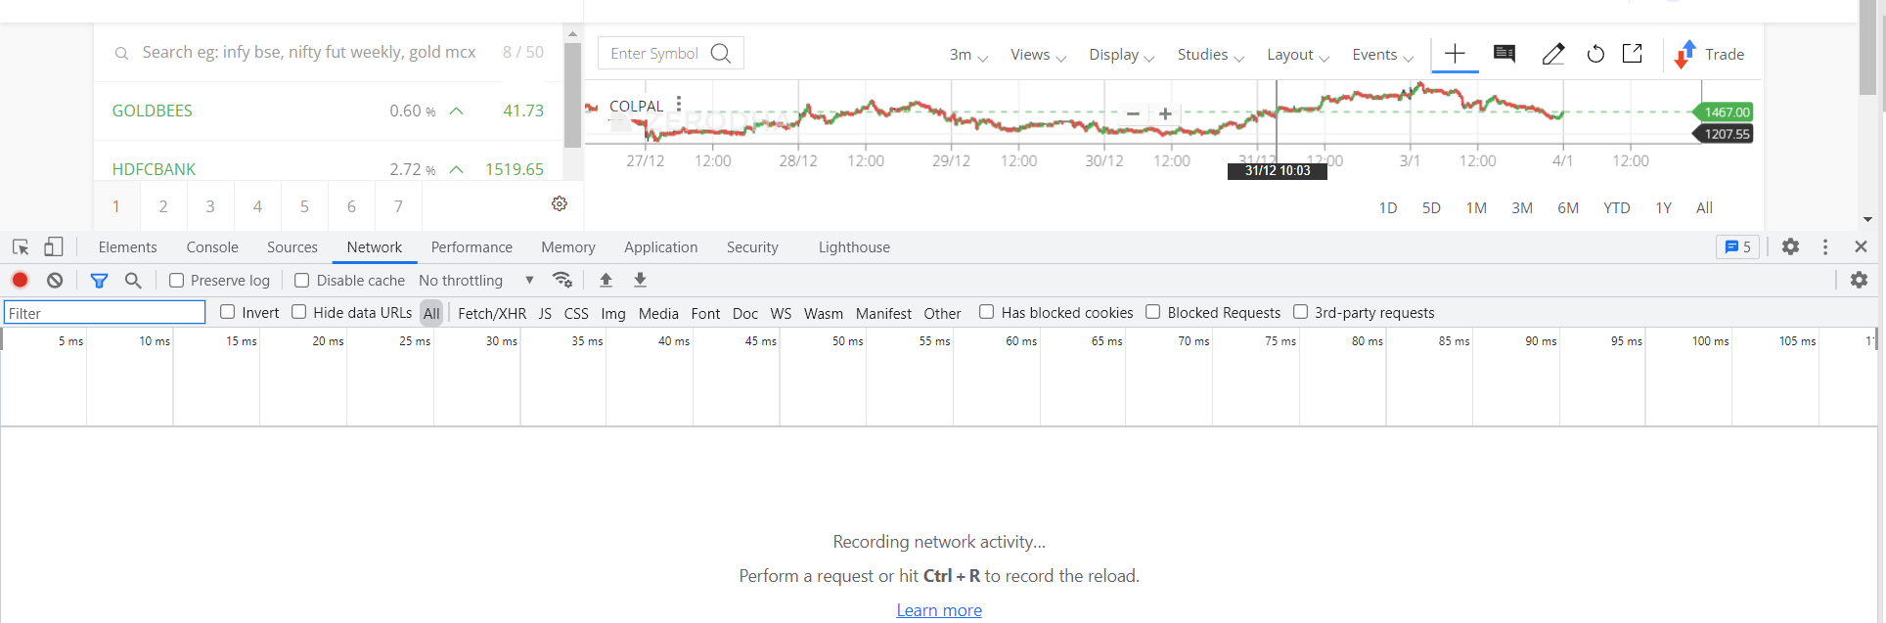

Click ctrl + r to reload the page and you get

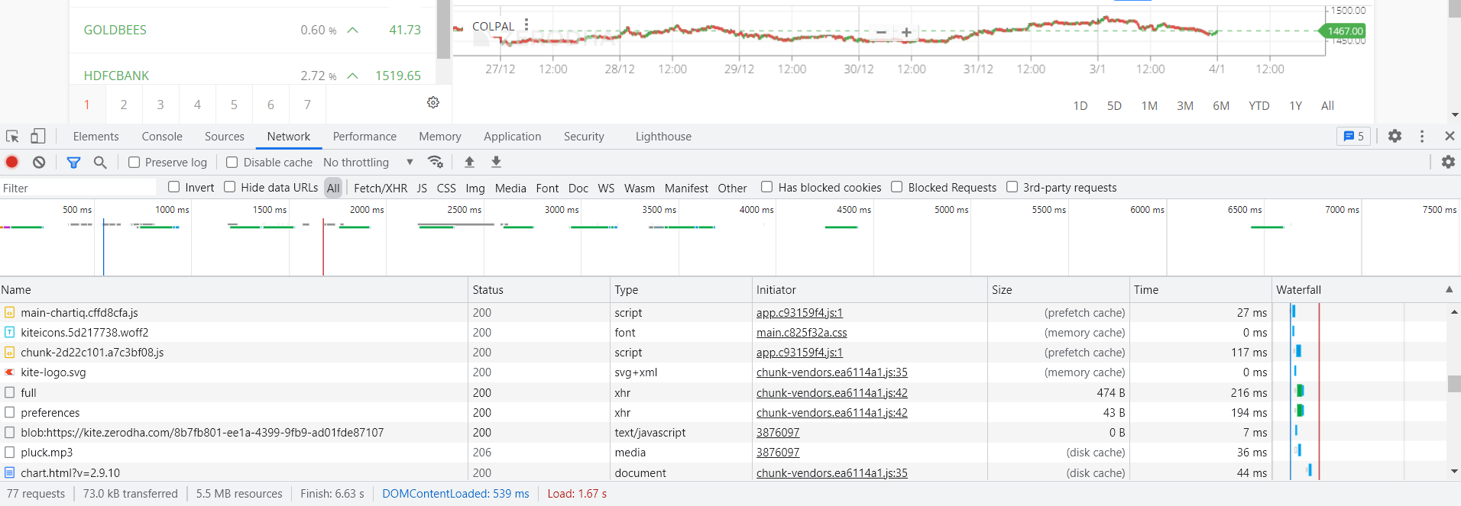

In this I clicked 3 minute option for the chart so hence I checked that and got the following window:

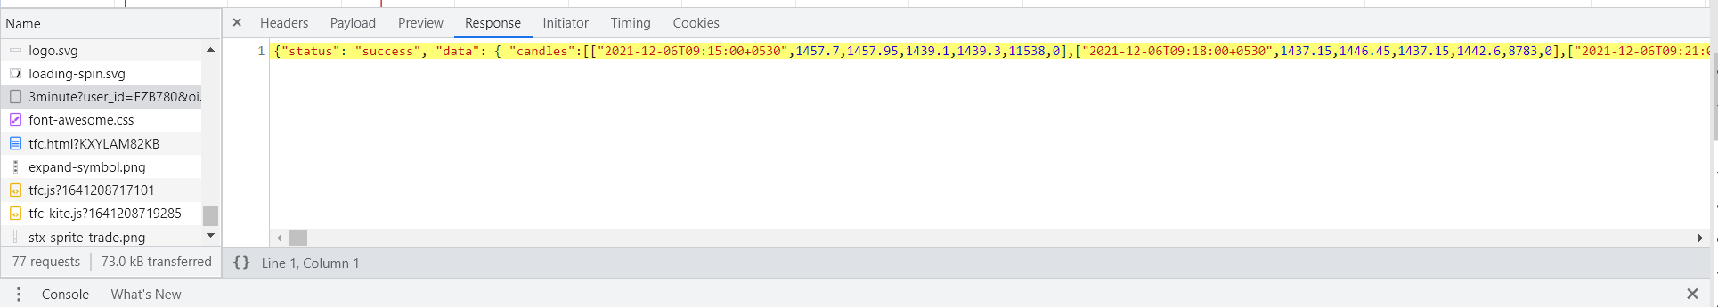

Select the entire thing in the yellow and paste it into a notepad++ file.

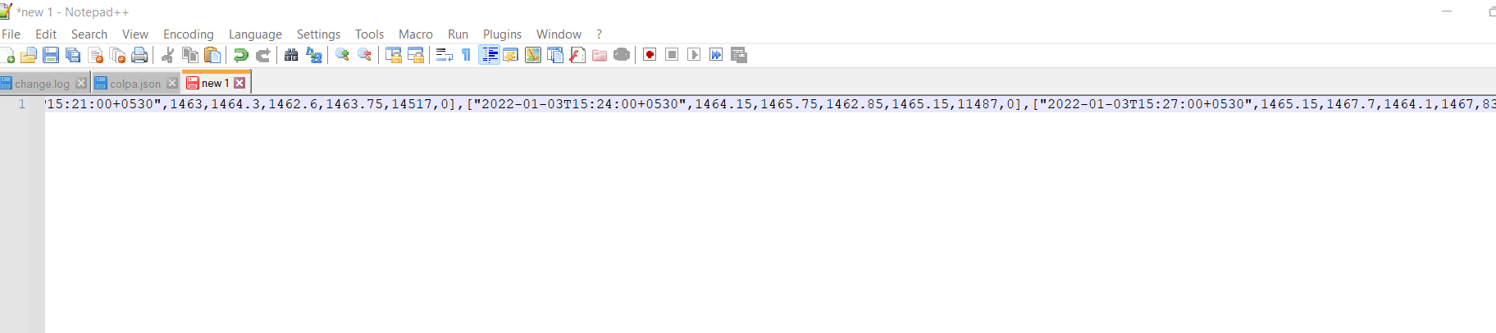

And save it as a json file

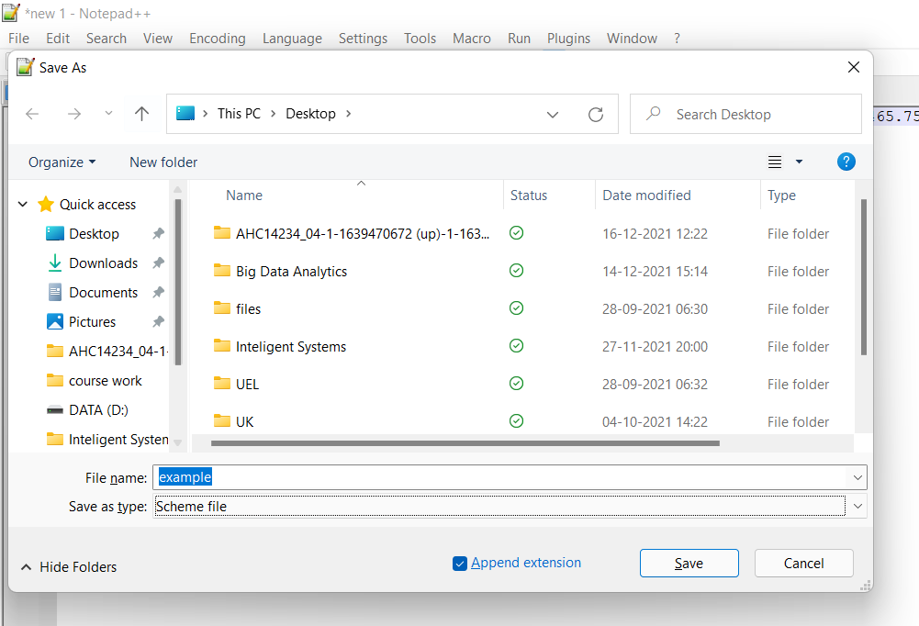

Now you have the data in json format.

Open colab and upload the file :

I have uploaded the colpal data I used earlier to do it in colpal

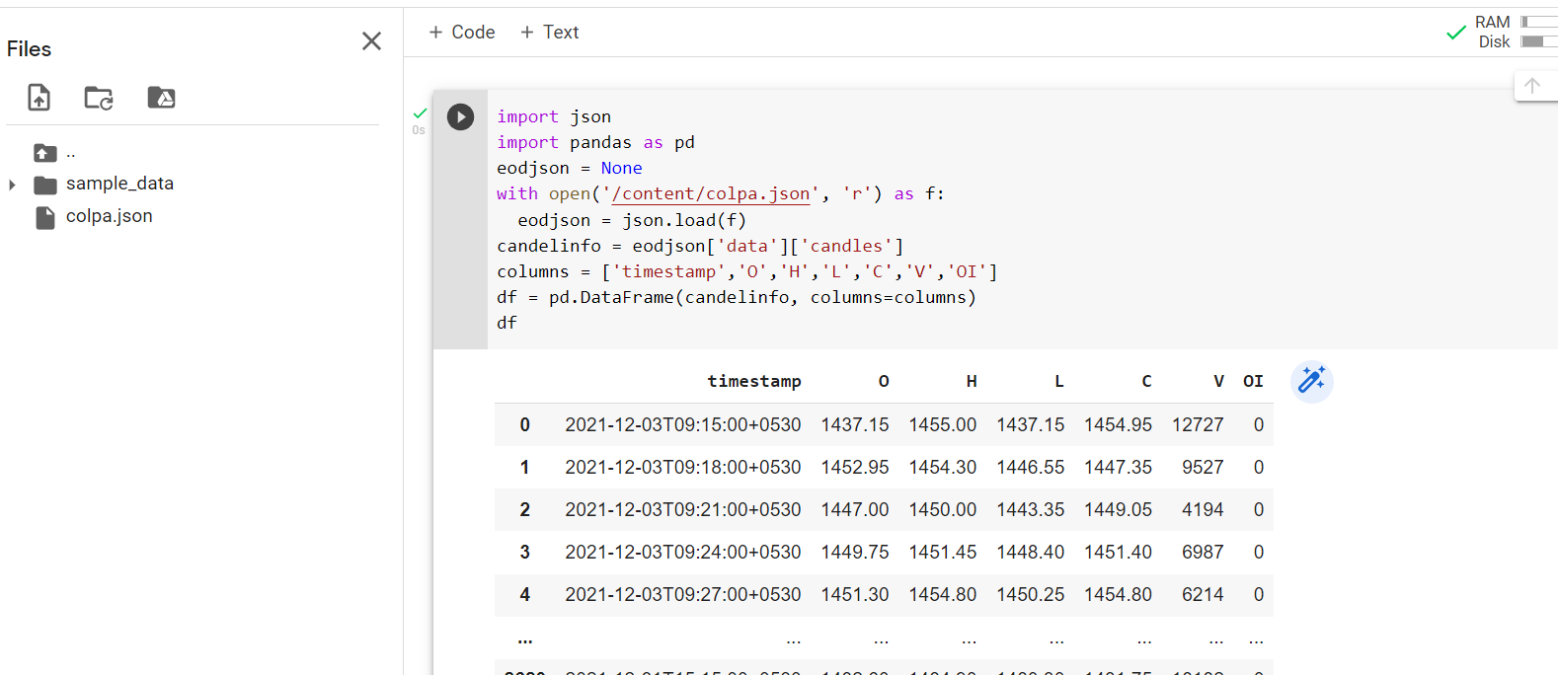

**CODE:**

import json

import pandas as pd

eodjson = None

with open('/content/colpa.json', 'r') as f:

  eodjson = json.load(f)

candelinfo = eodjson['data']['candles']

columns = ['timestamp','O','H','L','C','V','OI']

df = pd.DataFrame(candelinfo, columns=columns)

df

And if you want to convert it to excel:

**CODE:**

df['timestamp'] = pd.to_datetime(df['timestamp'], format = '%Y-%m-%dT%H:%M:%S')

df.to_csv('colpal.csv',header = True, index = False)